**Hello World Program**

In this section we will learn how to write the Hello World program, but wait I am curious about one thing-- Why do we need to start with **Hello World** to learn a new language every time, Ok then I did a little bit of research and found out that a chick is responsible for Hello World program.

Actually, "Hello, World” was created by Brian Kernighan, author of one of the most widely read programming books: C Programming Language, in 1978. He first referenced **Hello World** in the C Programming Language book’s predecessor. When asked what sparked the idea for the name “Hello, World” in an interview with Forbes India, he said his memory’s dim. “What I do remember is that I had seen a cartoon that showed an egg and a chick and the chick was saying, “Hello, World.” So, now you can interpret, why we start every time with this program!

Follow these steps to run your first Python program.

**Step 1:** Login to your Ubuntu server(Digital Ocean Droplet)

**Step 2:** Check Python version

**Step 3:** Create a Python File

**Step 4:** Run the python code

**Step 1:** Login to your Ubuntu server(Digital Ocean Droplet)

First, connect to the Ubuntu server with your username and password, as we have learned in previous sections.

**Step 2:** Check Python version

In Ubuntu 16.04 which is the version of Ubuntu installed on your Digital Ocean droplet, only Python-3 is available. To confirm the version of python, execute the command below on the terminal.

python3 --version

The above command would print the version of python as something similar to,

root@boltiot-learning-node:~# python3 --version

Python 3.6.5

Now we will run the "hello world" program in Python. Let see how it looks like.

**Step 3:** Create a Python File

First ssh into your Ubuntu server that you have deployed on Digital Ocean server and as I have mentioned in the previous section. We will use nano editor for writing the Python code because nano editor comes pre-installed with Ubuntu.

The command to be typed in the terminal to create a Python file is given below,

sudo nano filename.py

You may give any name as per your choice, however, make sure it ends with **.py** extension. In the below image, I am creating an empty python file with the filename "hello".

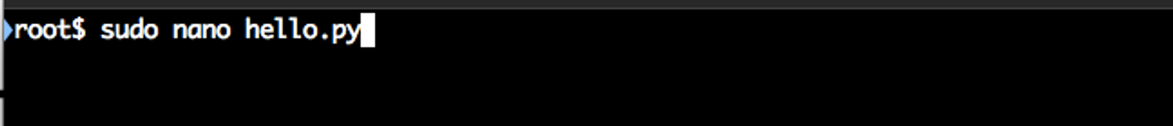

Press Enter key after you have typed the above command and it will open a nano editor for the hello.py file. You can write your Python code here.

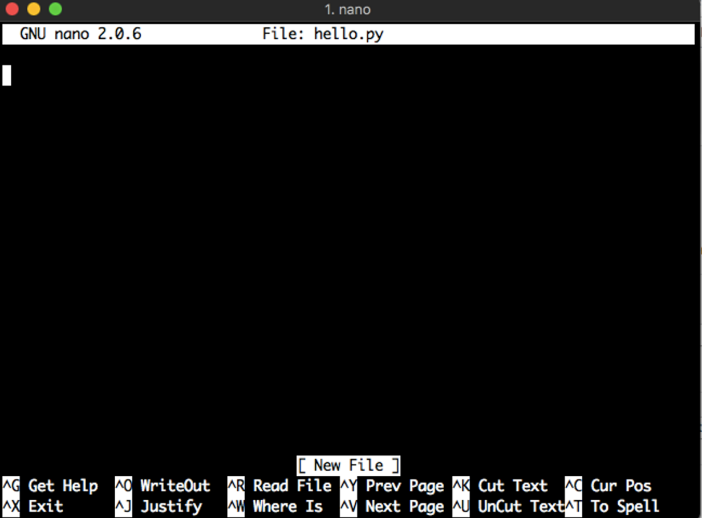

To print any information the syntax is print(). The print() function prints the given value to the standard output device. Also to print a string the command should be inside two double inverted commas. The code to print "Hello World" is,

print("Hello World")

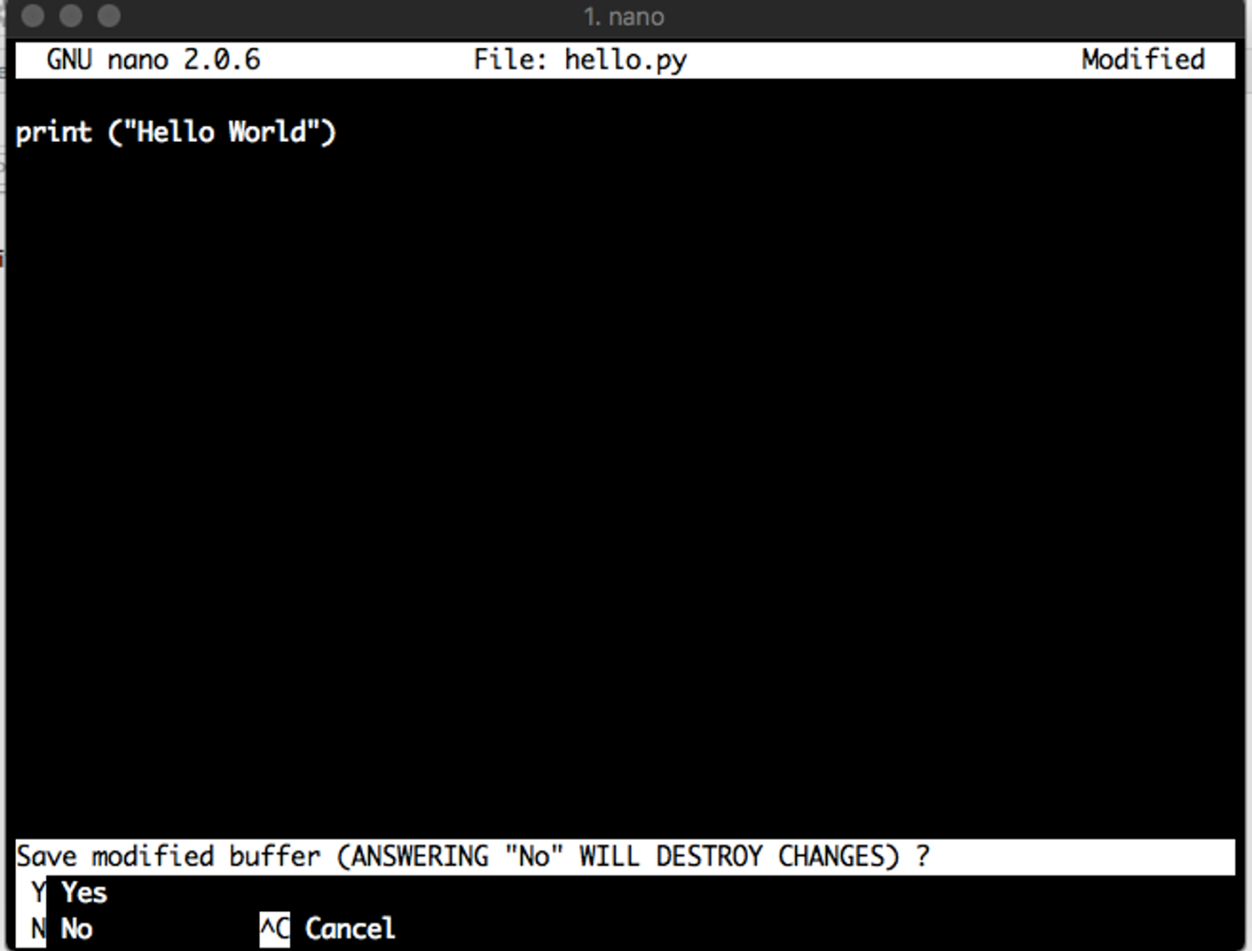

To save the file press Control + X key together on your keyboard, followed by letter ‘Y’ on your keyboard

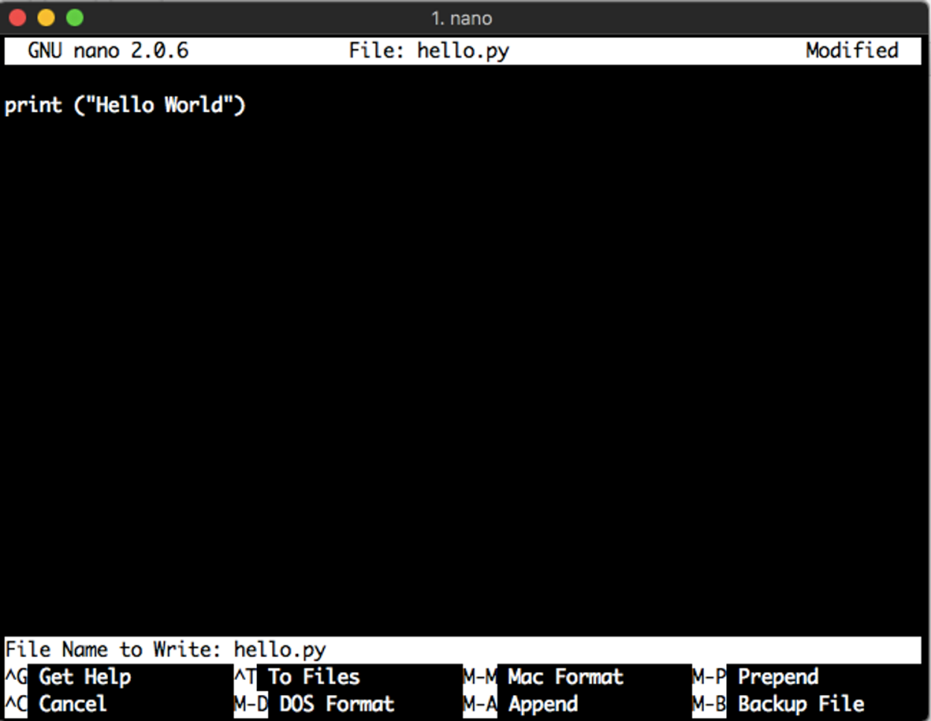

Press the Enter key on your keyboard to finally save the file.

**Step 4:** Run the Python code

The command to be typed in the shell to run a Python file is given below. Here "filename.py" is the name of the python file that we want to execute.

sudo python3 filename.py

For example, if I have created a python file with the name as my_python.py, I will need to execute the command,

sudo python3 my_python.py

As we have already written the hello world program in **hello.py** file, we shall run this Python file to see the output. Type the following command to run hello.py file in terminal,

sudo python3 hello.py

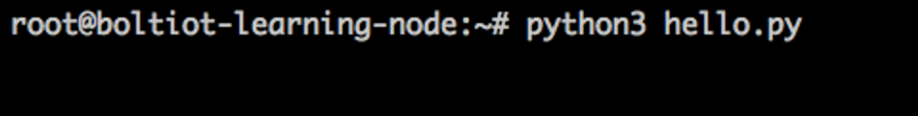

Press ‘Enter’ to get the output on your screen.

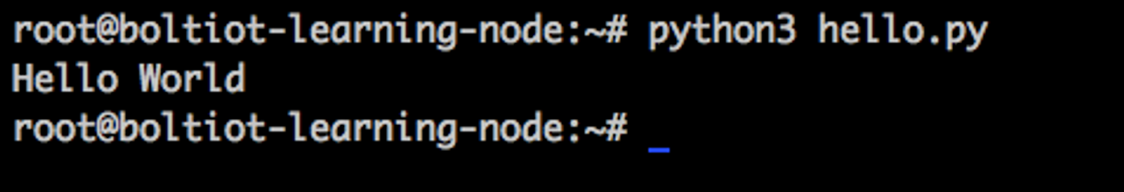

Error Debugging

If your code shows that there is an error then reopen the file you have created and the commands are the same as mentioned in the steps above. Once you have edited the file, you may save it the same way as shown before.